### Training Report

### On

**BILLING SYSTEM OF A SHOP**

**Submitted in partial fulfillment of the requirements**

**For the award of the degree of**

**Bachelor of Technology**

**In**

**COMPUTER SCIENCE**

**Submitted By**

**BHARAT BHUSHAN**

**2814058**

**Batch (2014-2018)**



**Panipat Institute of Engineering & Technology,**

**(Affiliated to Kurukshetra University Kurukshetra, India)**

**Samalkha, Panipat**

**(Session 2016-2017)**

**CANDIDATE’S DECLARATION**

I hereby declare that the work prescribed in this training report entitled **“Billing System Of A Shop”**, submitted for the requirement of the award of the degree of Bachelor of Technology in **Computer Science**, submitted to **Panipat Institute of Engineering & Technology, Kurukshetra University, Kurukshetra, India** is an authentic record of my own work carried out during the period from 7th July 2015 to 22nd Aug 2015under the guidance of **Mr.Pratik Bhandari(Infosol).**

The work reported in this project report has not been submitted by me for the award of any other degree or diploma.

5 Sept 2016 Bharat

Panipat 2814058

**i**

**CERTIFICATE**

This is to certify that the summer training report entitled **“Billing System Of A Shop”** done by **Bharat Bhushan, Roll No. 2814058** is an authentic work carried out by him at **Infosol Training Centre** under my guidance. The matter embodied in this training work has not been submitted earlier for the award of any degree or diploma to the best of my knowledge and belief.

Date: Trainer

**ii**

**Acknowledgement**

“Technology is like the ocean and an Engineer like a pearl driver in search of treasure, like treasure beneath the sea there is no end to professional technical studies but an engineer tries to get as much as possible.”

A work of this nature can never be done by any person alone. We have been able to bring this dissertation in the present shape only because of hearty co-operation of number of heads and hands. There are some who have blesses, some who have advised.

I am highly obliged to the professors at Panipat Institute Of Engineering And Technology who provided me the chance to undergo this training. I express my gratitude to **Miss Lipsa Ahuja** for guiding me**.**

I express thanks to **Mr. Pratik Bhandari**  for his valuable inputs during my training period.

I am very thankful to Training and Placement cell of **PANIPAT INSTITUTE OF ENGINEERING & TECHNOLOGY** without whom we wouldn’t have been able to get the development environment in the institute.

I also take the opportunity to thank our family for providing me every kind of help during the completion of this project.

At last but not the least I thank the technical and non-technical staff of PIET and INFOSOL and also my friend **Suraj** for his valuable co-operation.

Bharat Bhushan

2814058

**iii**

## Abstract

**Billing System Of A Shop** is a java based application which is made for billing out

Products of a shop namely “BBM Groups”.

**Importance**

The project consist of three major panels one for registration of both the staff members as well as the customers.

The next panel is the login panel for all the registered ones to perform the assigned work.

The major task of the staff members as well as the admin have the work to add products

As well as print the bill.

The user can login and view their purchases till date.

An another feature is to print the previous bill by using the unique bill number.

**Purpose**

There are many softwares available in the market for the same purpose.

But we realiazed that they were not so userfriendly. I just tried to build the program in a user friendly form.

**Conclusion**

**Project** is a kind of shop management which performs various operations on a single click. It is a User friendly and easy to use for every user. It will also reduce the head ache of those manual tensions.

**iv**

## cONTENTS

## Candidate's Declaration i

## Certificate ii

**Acknowledgement** iii

**Abstract** iv

## List of Figures viii

**Chapter No Description Page No.**

**Chapter 1: INTRODUCTION 1**

**Chapter 2: Software and Hardware requirements 2**

**Chapter 3: Software requirement analysis 3**

**3.1 Problem in SC 3**

**3.2 Functions and Module 3**

**Chapter 4: Software Design 5**

**Chapter 5: Coding / Source Code 7**

**v**

**Chapter 6: Testing 12**

**Chapter 7: Output Screens 14**

**Chapter 7: Conclusion 21**

**Chapter 8: Further Enhancements 22**

**Chapter 9: Bibliography 23**

**vi**

**List of Figures**

|  |  |  |
| --- | --- | --- |
| **Figure** | **Figure Name** | **Page no.** |
| Figure 4.2 | ER Diagram | 5 |
| Figure 4.3 | ER Diagram | 6 |
| Figure 7.1 | Main Screen | 14 |
| Figure 7.2 | Login Page | 15 |
| Figure 7.3 | Registration form(Customer) | 16 |
| Figure 7.4 | Registration form(Staff) | 17 |
| Figure 7.5 | Product Entry Panel | 18 |
| Figure 7.6 | Bill Printout | 19 |

**vii**

**List of Tables**

|  |  |  |
| --- | --- | --- |
| Table 7.1 | Testing of Billing System | 15 |
| Table 7.1 | Product Database | 20 |
| Table 7.2 | Customer Database | 20 |
| Table 7.3 | Bill Database | 20 |

**viii**

**Abbreviations**

BSOS : Billing System Of A Shop

Regis.:Registered

**ix**

**Chapter 1**

**INTRODUCTION**

**1.1 BILLING SYSTEM**

In the Today times Shop Management is a application which can manage all type of things to provide a proper facility to the customers and a better scope to the owner. So there is a need of shop management as it was not only related to the management of customers bills but also related to the keeping complete data-base records of the customers so in any case if any need arrive they can easily contact the administrators.

Different people has different views about shop management but the fact is that it is the software which has the main emphasis on the billing as well as storing the details of the products bought and sold.

The application is made for a particular for a hypothetical handloom showroom namely BBM Groups which deals with all handloom products may it bedsheets,curtains,blankets,pillows etc.

In order to keep in track of the products purchased by the suppliers ,also to avail an electronic bill to keep in track the total sale upto date.

In the particular application is a provision of customer registration to keep in track of his/her purchases such as to know whether they are regular or not. If yes will be provided with some limited discount on his current purchases.

Initially there is not a difference between staff members or the admin as both have the same task of either product entry or billing. But hopefully the updated version of the application would cover up the flaws.

**1**

**Chapter 2**

**SOFTWARE AND HARDWARE REQUIREMENTS**

**2.1 HARDWARE REQUIREMENTS:-**

* Intel®core(TM)I-3/I-5
* RAM 4 GB/8GB
* Hard-disk 500GB/1TB
* 32/64 Bit Operating System
* Printer

**2.2 SOFTWARE REQUIREMENTS:-**

* Operating System:- Windows 7 and above
* Technology:- Java
* Back End:- Xampp Data Base, jdk 6and above

**2**

**Chapter 3**

**SOFTWARE REQUIREMENT ANALYSIS**

**3.1 Problems**

The major problems that exist for any shop is the manual work they perform ,the headache of maintaing the bill books years to years.

The manual bills are also porne to physical damage such as the weather conditions.

Moreover if for any reason the bills have to be searched its like finding a needle from a cotton sack. All such problems have a single solution and that is this application along with database connectivity perfectly designed for such problems.

**3.2 Functions and Module**

BSOS is an application with many functions in it as given below.

**Registration Module:**

In BSOS the regis. form is reached via the regis. Button available on the home page.

It provides the regis. Panel where any new staff member is registered. Also the customers are registered on the same panel. They are provided with a unique id which could be very much helpful during their next purchases. Both are facilitated by a single userId.

Customers would get a discount and the cashier will be relived from typing the entire details of the user again and again.

**Login Panel:**

To allow the registered ones may it be the staff members or the customers to have access on what they have been provided. The staff members and the admin both have the permission to add the products purchased from the suppliers, what the quantity is,what would be the selling price etc.

The second task of the staff members is to handle the billing og the sales.

Customers who are logged in have only the permission to view the purchases they have

Done upto date.

3

**Billing Portal:**

If staff member choose the operation of billing the concerned is transferred to a billing

Form which allows to enter the user id as well as the product number of at most of four products and the respective quantity. On the same frame is available a button on click of which is executed the bill only if there is no mistake. The application provides automatic data filling feature that is by just providing product number it autofills the product details , also by just providing the userid the bill is updated with the necessary details of the customer.

**Contact-us Module:**

This module is generally used to provide a contact information to the customer about the shop so he/she will remain touch with the department so whenever any problem is occurred related to the product would directly contact to the concerned and tell him about the query and get a solution of the problems.

**Back End Working:**

The best part of the project is the back end working that is the entire front setup is connected with the database in avery secure server namely xampp. May it be the registration or the billing portal the entire data is transfred to its respective table which is allotted to it. Using the SQL Queries we could easily access those tables whenever required. Probably the customers presently are not provided with much of facilities but hoping that the updated version would see some more betterment .

4

**Chapter 4**

**Software Design**

**4.1 ER Diagrams**

An Entity relationship diagram are generally used to represent the relationship between different attributes of the entities. An entities just look like an object about which any type of information can be stored in the system data-base. ER Diagram make use of different symbols to represent different kind of info. Ovals are generally used to represent different attributes. Diamonds are generally used to represents relations. Boxes are generally used to represent entities.

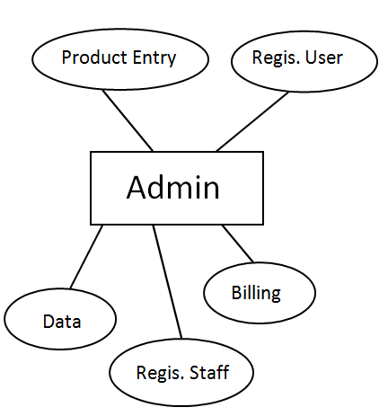

**4.2 ER Diagrams on BBOS**

**5**

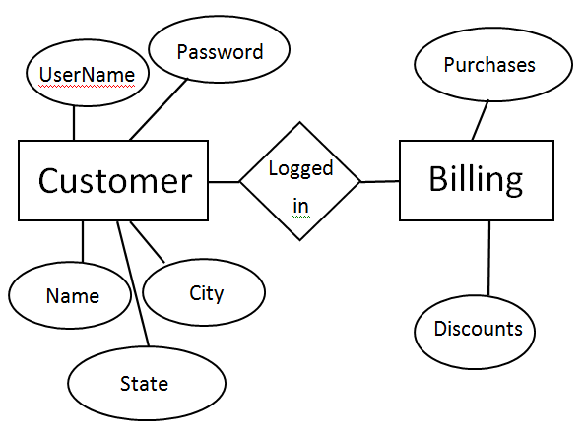

**4.3 ER Diagram :**

**6**

**Chapter 5:**

**SOURCE CODE**

**Main Source Code**

import java.awt.*;

import java.awt.event.*;

import javax.swing.*;

public class bbm1 extends JFrame implements ActionListener {

JPanel p1,p2,p3,p4,p5,p6;

JButton b1,b2,b3,b4,b5,b6,b7,b8,b9,b10;

JLabel l1,l2,l3,l4,l5,l6,l7,l8,l9,l10,l11,l12,l13,l14,l15,l16,l17;

JLabel l18,l19,l20;

login l;

bbm1()

{

Font f=new Font("Modern No. 20",Font.BOLD, 25);

Font f1=new Font("Lucida Handwriting",Font.BOLD, 60);

Font f2=new Font("Baskerville Old Face",Font.BOLD, 20);

Font f3=new Font("Baskerville Old Face",Font.BOLD, 17);

Font f4=new Font("Imprint MT Shadow",Font.PLAIN, 30);

Font f5=new Font("Copperplate Gothic Bold",Font.BOLD, 17);

Font f6=new Font("Lucida Calligraphy",Font.BOLD,17);

Font f7=new Font("Lucida Handwriting",Font.BOLD,50);

Font f8=new Font("Aerial",Font.PLAIN,25);

setVisible(true);

setSize(900,800);

setLayout(null);

p1=new JPanel();

p2=new JPanel();

p3=new JPanel();

p4=new JPanel();

p5=new JPanel();

**7**

l=new login();

p1.setBounds(0,0,900,170);

p2.setBounds(0,170,900,30);

p3.setBounds(0,200,900,100);

p4.setBounds(0,300,200,500);

p1.setBackground(Color.white);

p2.setBackground(Color.white);

p3.setBackground(Color.white);

p4.setBackground(Color.white);

p1.setLayout(null);

p2.setLayout(null);

p3.setLayout(null);

p4.setLayout(null);

p5.setLayout(null);

add(p1);

add(p2);

add(p3);

add(p4);

add(p5);

add(l);

l1=new JLabel(new ImageIcon("img/logo.gif"));

l2=new JLabel("BBM GROUPS");

l3=new JLabel("Symbol of trust and Quality");

l4=new JLabel("No.4 Dharamshala Road ");

l5=new JLabel("Jharia,Dhanbad");

l6=new JLabel(new ImageIcon("img/panelpic.gif"));

l7=new JLabel("Product ");

l8=new JLabel("Categories");

l9=new JLabel("HOME");

l10=new JLabel("Welcome to THE BBM GROUPS,");

l11=new JLabel( "Explore a fine range of handloom items like Bedsheets,Bedcovers,");

l12=new JLabel("Cushions, Quilts, and more.");

l13=new JLabel("Being a premiere manufacturer, exporter, trader & supplier ");

l14=new JLabel("having a proven track record in the industry, we offer a wide ");

l15=new JLabel("range of quality-assured handcrafted products to our customers");

l16=new JLabel(new ImageIcon("img/curt2.gif"));

l17=new JLabel(new ImageIcon("img/bed2.gif"));

**8**

l18=new JLabel(new ImageIcon("img/bed1.gif"));

l2.setFont(f1);

l3.setFont(f2);

l4.setFont(f3);

l5.setFont(f3);

l7.setFont(f4);

l8.setFont(f4);

l9.setFont(f7);

l10.setFont(f6);

l11.setFont(f6);

l12.setFont(f6);

l13.setFont(f6);

l14.setFont(f6);

l15.setFont(f6);

l2.setForeground(Color.gray);

l9.setForeground(Color.red);

l1.setBounds(0, 40,160, 80);

l2.setBounds(180, 50 , 500, 60);

l3.setBounds(500, 90, 300, 60);

l4.setBounds(670, 10, 350, 20);

l5.setBounds(670, 30, 350, 20);

l6.setBounds(0,0,900,100);

l7.setBounds(5,0,180,60);

l8.setBounds(13,30,180,65);

l9.setBounds(250,10,250,50);

l10.setBounds(100,70,600,20);

l11.setBounds(20,100,680,20);

l12.setBounds(20,130,600,20);

l13.setBounds(20,180,680,20);

l14.setBounds(20,210,680,20);

l15.setBounds(20,240,680,20);

l16.setBounds(180,280,150,150);

l17.setBounds(10,280,150,150);

l18.setBounds(50,280,600,150);

b1=new JButton("Home");

b2=new JButton("Login");

b3=new JButton("Registration");

**9**

b4=new JButton("About");

b5=new JButton("Contact us");

b6=new JButton("Bedsheets");

b7=new JButton("Curtains");

b8=new JButton("Blankets");

b9=new JButton("Covers");

b10=new JButton("Furnish");

b1.setBounds(170,3,80,20);

b2.setBounds(260,3,80,20);

b3.setBounds(350,3,130,20);

b4.setBounds(480,3,80,20);

b5.setBounds(570,3,110,20);

b6.setBounds(30,125,120,20);

b7.setBounds(30,175,120,20);

b8.setBounds(30,225,120,20);

b9.setBounds(30,275,120,20);

b10.setBounds(30,325,120,20);

b1.setBackground(Color.white);

b2.setBackground(Color.white);

b3.setBackground(Color.white);

b4.setBackground(Color.white);

b5.setBackground(Color.white);

b6.setBackground(Color.white);

b7.setBackground(Color.white);

b8.setBackground(Color.white);

b9.setBackground(Color.white);

b10.setBackground(Color.white)

b1.setForeground(Color.green);

b2.setForeground(Color.green);

b3.setForeground(Color.green);

b4.setForeground(Color.green);

b5.setForeground(Color.green);

b6.setForeground(Color.blue);

**10**

p4.add(b6);

p4.add(b7);

p4.add(b8);

p4.add(b9);

p4.add(b10);

p5.add(l9);

p5.add(l10);

p5.add(l11);

p5.add(l12);

p5.add(l13);

p5.add(l14);

p5.add(l15);

p5.add(l18);

} //end of constructor

public void actionPerformed(ActionEvent e)

{

if(e.getSource()==b1)

{

p5.setVisible(true);

}

else if(e.getSource()==b2)

{

p5.setVisible(false);

l.setVisible(true);

}

}

public static void main(String args[])

{

new bbm1();

}

void close()

{

this.setVisible(false);

}

} //end of class

**11**

**Chapter 6**

**Testing**

Testing is the process of displaying the incorrectness and considered to success when an error is detected. Testing is not a distinct phase in system development life cycle but it will also applicable throughout all the phases i.e. maintenance phase and system development phases. Software testing is the main part of testing which is generally used to find the error as early as possible so it can be saved for the future purpose. Generally no system is completely efficient due to communication problems between different users and system developers. Testing is the type of approach which is used to find that the various features

of Software is adequately constructed.

**Principles of Software Testing:**

* **Traceablity of errors:**

Tests should be conducted in such a way so it will be easily traceable according to the customer require due to the resources limit is decreases.

* **Less Testing time:**

Testing must be pre-planned which will be very useful for proper utilization of all type of resources which is very needful for making the testing efficient and perfect.

* **Strategy for Software Testing:**

Strategy for testing can be prepared by using different levels of testing.

* **Unit Testing**: This is one of the most popular testing which is generally used to test the invidual components itself and remove the errors of all the unit invidually.
* **Integrated Testing:** Second one is Integrated testing which perform the task of Integrating all the coding modules into a single modules so they will be tested as a single unit.
* **Acceptance Testing:** This testing is generally used to qualify that the project represented by the user accepted or not for the higher software development levels.

**12**

|  |  |  |  |
| --- | --- | --- | --- |
| **S.No.** | **Test cases** | **Positive Response** | **Negative Response** |
| 1. | Main Panel | Go to Main Panel | System Error |
| 2. | Manager login | Successfully login | Invalid username and password |
| 3. | Customer login | Successfully login | Invalid username and password |
| 4. | Customers Details | For Registration | Failed to add details |
| 5. | Billing form | form will be available | Nothing will be display |
| 6. | Bill printing | Bill will be printed | Failed to print |
| 7. | Customers Database | Details shown in table | No table is displayed |

**Table 6.1 Testing of Billing System**

**13**

**Chapter 7:**

**OUTPUT SCREENS**

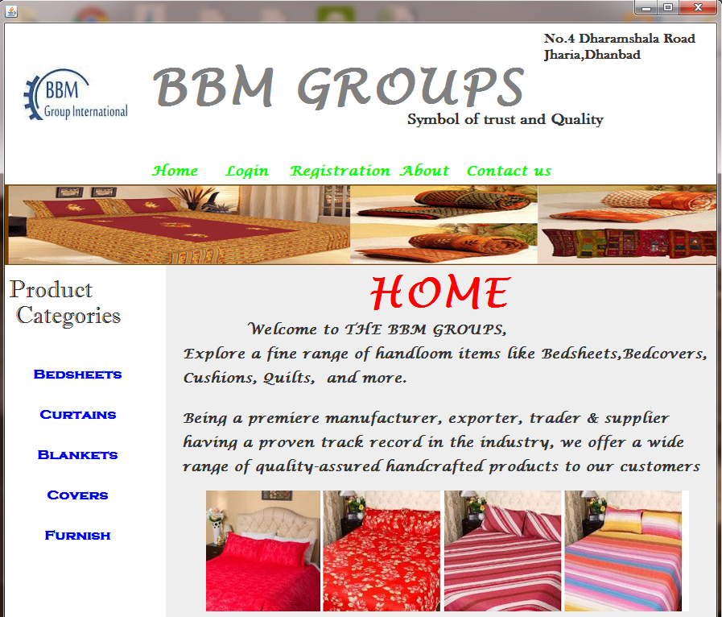

Figure 7.1 Main Screen

**14**

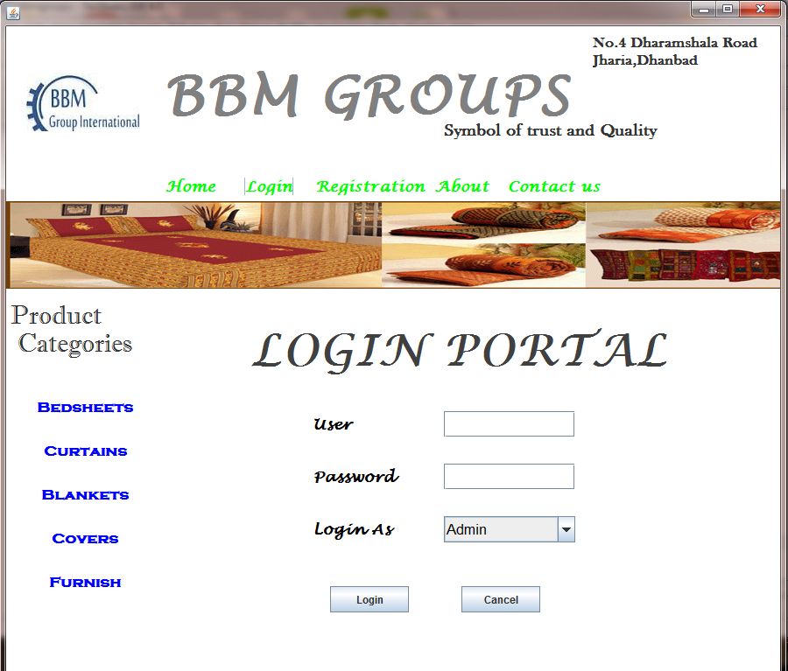

Figure 7.2 Login Page

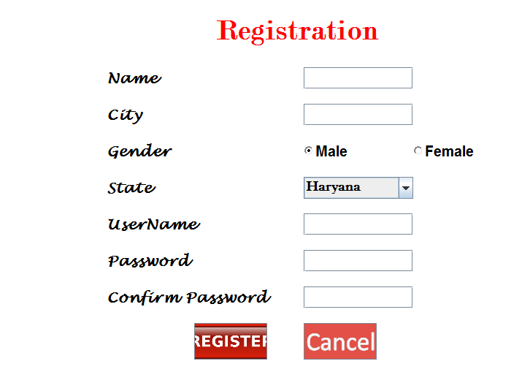

Figure 7.3 Registration form(customer)

**16**

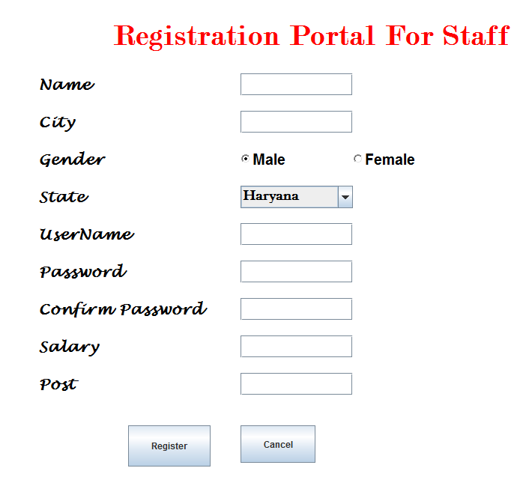

Figure 7.4 Registration form(Staff)

**17**

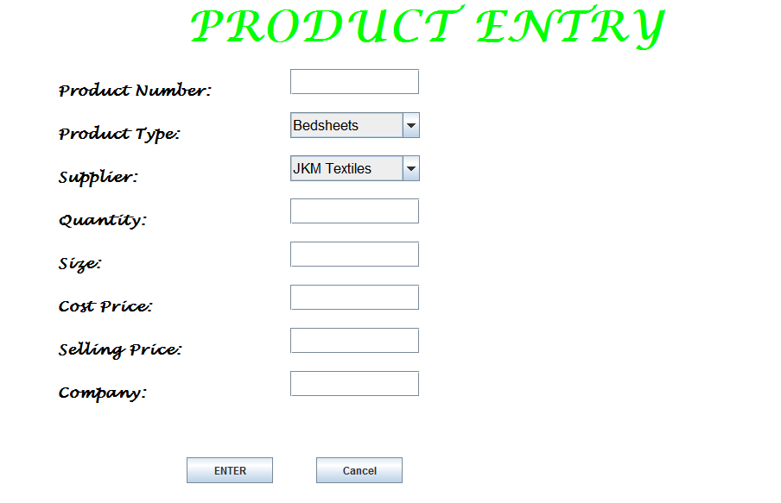

Figure 7.5Product Entry Panel

**18**

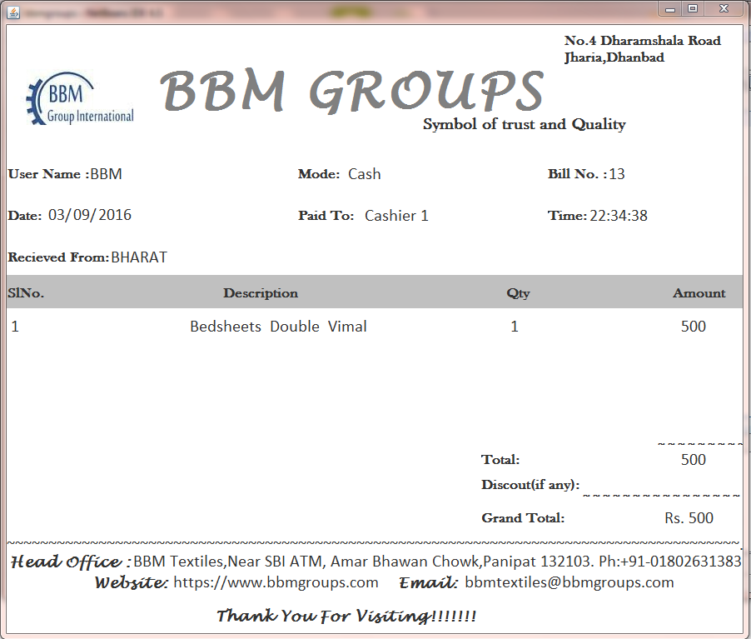

Figure 7.6 Bill Printout

**19**

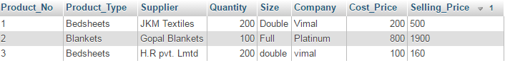

Table 7.1 Product Database



Table 7.2 Customert Database

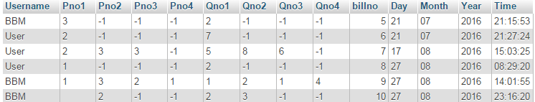

Table 7.3 Bill Database

**20**

**Chapter 8**

**CONCLUSION**

Billing System of a Shop is a very good software which works in a reliable and easy way. The main thing of this BSOS it performs all operation on a single click. This application is totally based on the Graphical User Interface so in using it no problem may occur. It can be used by every person very easily. The main thing of this project is that it performs billing operations in very efficient way and is very fast. It also calculates the total sale accordingly in a very efficient manner and in easy way.

In the end I want to say that it is very good software for business professionals and for students also.

**21**

**Chapter 9**

**FURTHER ENHANCEMENTS**

BSOS can perform many useful operations and in future many more operations can be add in it for further enhancement which make it more suitable for any purpose use.

These are the following operations which can be add in the BSOS in future.

1. **Profit loss maintance**

Probably a well maintained profit loss statements would be introduced taking the database into considered.

1. **Return Option**

The current version lacks the option of the returning of any product and is a big disadvantage as any one may be required to return the product for any reason.

1. **Conversion to a Proper Shop Management System**

The important point regarding the application is that its ultimate version would be a transformation of the application to a complete different level that is a proper shop management system.

1. **Additional feature for wholesalers**

The current version is made keeping in mind the requirements of a retailer.

It may not be applicable to any of wholesalers so a feature regarding the bulk sale purchases made by the wholesalers would be new add on.

1. **Addition of more of products**

Last is that the current version is able to bill a maximum of four products but a add on would be that in future the maximum number of products would be increased to better number.

**22**

**Chapter 10**

**BIBLIOGRAPHY**

* Google
* Oracle
* Youtube
* **Book References :**
* [1] Java: The Complete Reference, Herbert Schildt
* [2] Java Programming , Dr. R.S. Grewal VSM
* [3] Head First Java

**23**